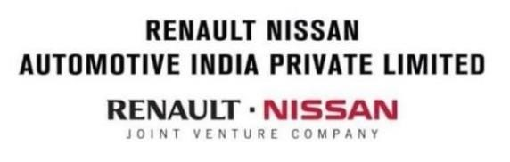

**INTERNSHIP FINAL REPORT**

**NAME:** S.V.NITEESH

**INTERN ID:** INT01459

**UNIVERSITY:** SRM INSTITUTE OF SCIENCE AND TECHNOLOGY,RAMPURAM

**EDUCATION PROGRAM:** B.tech: Computer Science Engineering specialization with Big Data analytics

**INTERNSHIP DATE:** 18th December 2023-18 January 2024

**INTERNSHIP ORGANISATION:** Renault Nissan Automotive India Private Limited (RNAIPL)

**TABLE OF CONTENTS**

|  |  |  |
| --- | --- | --- |
| **S.NO** | **TOPICS** | **PAGE NO.** |
| 1. | ACKNOWLEDGEMENT | 3 |
| 2. | BONAFIDE CERTIFICATE | 4 |
| 3. | INDUCTION PROGRAM | 5 |
| 4. | INTRODUCTION | 13 |
| 5. | MY WORK AND LEARNINGS | 22 |
| 6. | CONCLUSION | 35 |

**ACKNOWLEDGEMENT**

I would like to express my profound gratitude to **Renault Nissan Automated India Private Limited (RNAIPL)** for giving me the invaluable opportunity to engage in an internship within their esteemed organization. My gratitude extends to **Mr. Vijaykumar Selvaraj** sir whose leadership has been instrumental in shaping my experience. I thank **Mr. Vinoth** sir, my mentor, and the entire ISIT team for their unwavering guidance and support throughout this transformative journey.

I would like to thank **Mr. Paulraj** sir from the HR department for his assistance in facilitating this internship opportunity. His coordination has been vital in ensuring a smooth and enriching experience.

This internship has not only provided me with industrial insights but has also significantly deepened my understanding of the Data Analytics sector. I am grateful for the knowledge and practical experience gained, which I believe will contribute immensely to my professional growth.

NITEESH S V

**BONAFIDE CERTIFICATE**

I hereby certify that the report has been entirely done and submitted by **NITEESH S V(INT01459)**, a student in their second year of the B. Tech program in Computer Science Engineering in specialization with Big Data Analytics at SRM Institute of Science and Technology Ramapuram, Chennai. he has successfully completed his internship under our supervision at Renault Nissan Automated India Private Limited, actively engaging in the program from December 18, 2023, to January 18, 2024.

Date:

**SIGNATURE OF MENTOR**

Name of the Mentor: Mr. Vinoth

Renault Nissan Automated India Private Limited, Oragadam, Chennai-602105

**INDUCTION PROGRAM**

**Safety Briefing**

* No walking while talking on the phone.
* It is mandatory to wear safety shoes inside shop floor.
* Safety helmet and goggles are to be worn for Stamping and Body Shop floors.
* Always be aware of your surroundings. Only use Walkway and not Gangway inside Shop floor.
* Taking photo inside the plant is prohibited.

**INTRODUCTION**

The Renault Nissan Automotive India Private Limited (RNAIPL) is a plant that is formed with 5 companies administration under it such as:

-Renault India Private Limited (RIPL)

-Nissan Motor India Private Limited (NMIPL)

-Renault Nissan Automotive India Private Limited (RNAIPL)

-Renault Nissan Technology and Business Centre India

-Renault Nissan Financial Services India Private Limited.

The Plant is a 620 Acres Plant. apart from this, there is a separate 200 acres supplier area which also belongs to RNAIPL. The plant currently runs at 33 JPH, which was 42 JPH previously. This reduction was because of factors such as semi-conductor shortage.

Therefore, we can see that one car is being manufactured every 1.81 minutes.

The Renault Nissan Automotive India Private Limited is formed by a 50:50 joint venture between Renault and Nissan to manufacture passenger vehicles in India. The alliance works out of its Oragadam plant which started on 17th March 2010 in Chennai. The Renault-Nissan facility has been catering not just to the domestic demand but exporting a significant number of volumes overseas. This plant was started with an initial investment of a minimum of s 4,500 crore. The plant has a capacity of 480,000 vehicles per annum,12 million gearboxes. The company revealed that the 3.5 millionth engine to rollout was the HRAD turbo that powers the Nissan Magnite. This plant is also the first in the Indian automotive sector to locally build one lakh engines in just 14 months. The plant produced one million engines in just six years, while the rest 2.5 million power trains were built in the next x years.

At present, the Renault-Nissan Alliance produces 6 engine variants and 4 gearbox options at the facility.

RNAIPL has achieved production target of 5,00,000 lakhs vehicle in the month of

October 2013 in the short span of 40 months after start of production. On 24th

November 2020, Renault-Nissan India Records 1 million Car Export Milestone. The Renault-Nissan India Alliance Plant (RNAIPL) in Chennai, India, has achieved a new milestone with the rollout of the 3.5 millionth power train unit from the facility. The automaker began engine production at the Chennai plant in 2010 and the facility has produced 2.3 million engines and 1.2 million gearboxes. The company revealed that the

3.5 millionth engine to rollout was the HRAD turbo that powers the Nissan Magnite. This plant is also the first in the Indian automotive sector to locally build one lakh engines in just 14 months. The plant produced one million engines in just six years, while the rest

2.5 million power trains were built in the next six years. At present, the Renault-Nissan Alliance produces 6 engine variants and 4 gearbox options at the facility.

The Renault-Nissan Alliance plant builds a number of models including the Nissan Magnite, Kicks, Sunny, as well as the Renault Kwid, Kiger, and Triber. Nissan India exports the Magnite to 15 countries worldwide including South Africa, Nepal, Indonesia, Bhutan, Sri Lanka, Bangladesh, Brunei, Kenya, Seychelles, Uganda, Mozambique, Zambia, Mauritius, Tanzania, and Malawi.

**Current models in production:**

Renault: KWID, TRIBER, KIGER



Nissan: KICKS, SUNNY, MAGNITE





**STAMPING**



Fig.



Process flow in RNAIPL



Stamping involves placing flat sheet metal, in either coil or blank form, into a stamping press In the press, a tool and die surface form the metal into the desired shape. Punching, blanking bending coining embossing, and flanging are all stamping techniques used to shape the metal.



Fig. Process flow chart followed in Stamping shop

**Raw Material used:**

SPCC-Cold Rolled Carbon Steel Sheets and Strip (SPCC) is a Japanese industrial standard for cold rolled steel.

GA-Galvanized steel sheets (GA) have become the mainstream steel sheet for automobile applications because of their superior corrosion resistance, painting ability, and welding ability.

Gl-Galvanized iron (GI) sheets are basically steel sheets which have been coated with zinc.

First Operation that takes place in stamping is Blanking.

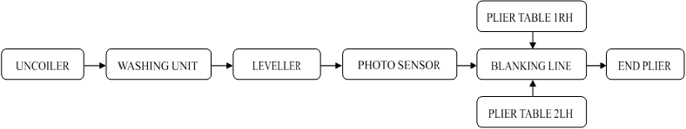

Fig. Blanking process flow

Types of Defects:

 Bump

* Dent
* Neck

Quality Checking methods used:

 Oil(Highlight Checker)

* Landfill Checker
* Oil Stone Check

Dies are classified based on their operation as follows:

 PA Die:Blanking

* PB Die:Drawingg
* PC Die : Excess cut
* PD Die: Hemming

The output from stamping shop is feed to body shop .

BODY SHOP:

The function of body shop is to assemble various parts produced in press shop using welding processes. Generally, the body shop is divided into many sub-assembly lines. Each sub-line represents a welding area covering numerous welding operations in different stations.

In Body Shop Majority of operations are carried out by robots. Various Techniques such as Spot welding, Seam welding, Mig welding, hemming (Door assembly) etc., are used for assembly of sheet metal parts. The Fit & Finish and other aspects are checked in the Metal line.

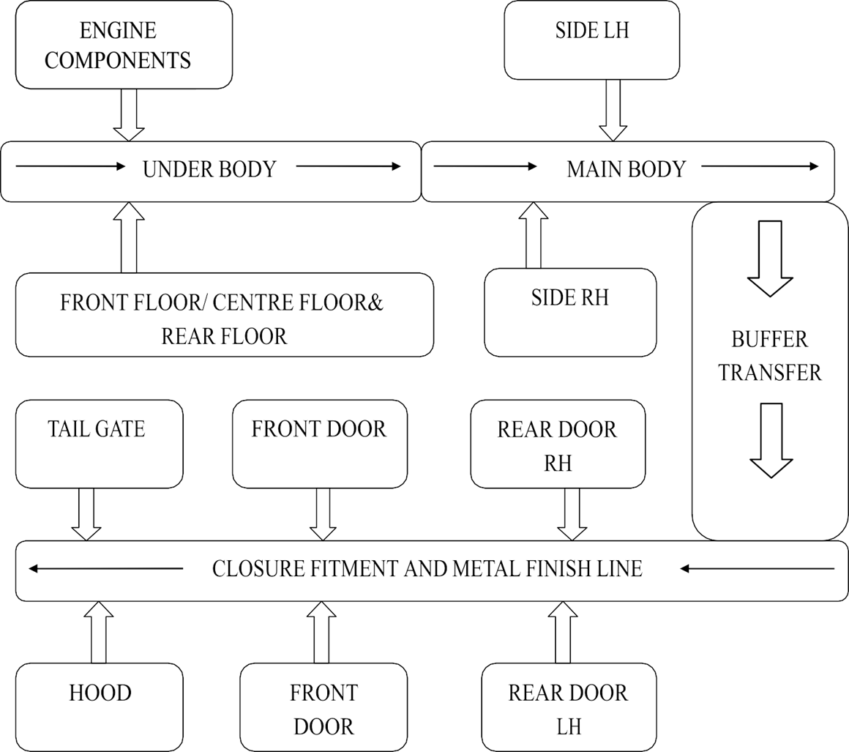

There are 3 lines in Body Shop:

* Line 1-Sunny and Kicks
* Line 2-Kiger, Magnite and Triber
* Line 3-Kwid

In-House Quality Assurance team (IHQA) take care of the quality control in Body Shop. In Body Shop, the 5 main pillars used to define quality of the output are:

1. Spot Welding
2. Sealer
3. Dimensional Accuracy
4. Fit and Finish
5. Surface Finish

After the completion of all these processes, the car is moved to Paint Shop

**PAINT SHOP**

Paint Shop consists of two lines. The Chassis that is received from Body Shop undergoes the following processes:

1. Pre-Treatment line
2. Electro-Deposit line
3. ED Oven
4. Sealer Zone
5. ED Sanding Zone
6. Body Arranging Zone
7. Dust off Zone 8. Topcoat Zone

**Pre-Treatment line**: Degreasing, Raw water rinsing, conditioning, Phosphate treatment, De- ionized water rinsing.

**Electrode Deposit line**: ED bath, Ultra Filtrate, Fresh water bath and tilting.

**ED-Oven**: For drying of paint.

**Sealer Zone**: Resist leakage through car body.

**ED Sanding Zone**: sanding to make paint layer uniform.

**Body Arranging Zone**: Side line Buffer for grouping same color bodies, Main line- Scanning barcode and sent to CCR panel, Repair line- Repairs after ED sanding done here.

**Dust off Zone**: Dust from body is removed before topcoat.

**Topcoat zone**: Anti corrosion coating, primer coating, base coating, Final Clear coating.

The chassis is then transferred to Trim and Chassis Shop.

**PLASTIC SHOP**

In Plastic shop, Bumpers are manufactured in house by the process of injection molding. They are manufactured by both Mechanical and Electrical Injection molding press After this process,the Bumpers are taken to Bumper paint shop where similar painting operations done followed by quality check. With the help of punching machines, holes are made in bumpers for fixing lights and various other sensors. From there these bumpers are taken to Trim & Chassis shop for assembly.

**TRIM AND CHASSIS SHOP**

Different parts of the car are fully assembled into the chassis here. There are two lines here:

Line 1: Sunny and Kicks

Line 2: Kwid, Triber, Kiger, Magnite

In total, there are 9 zones for one line in Trim and Chassis. They are:

1. Trim A
2. Trim B
3. Under Floor
4. Engine-Sub Assembly
5. CUBS Line (Complete Underbody System)
6. Chassis Trim
7. Door Sub
8. Pre-Final Line
9. Tester Line

**TRIM-A:**

 Engine room harness fixed

* Engine mounting bracket (LH, RH)
* Backdoor finishing (lock, striker, stay latch)
* Door off (door removed from the body and sent to door sub line tocomplete the door Sub assembly)
* Headliner fixing (completion of the roof)
* Brake and clutch pedal mounting
* Seat belt fixing
* Airbag fixing

**TRIM-B:**

* CCB member mounting (CCB member assembly is mounted with SMM manipulator)
* IP completion (instrument panel-mounted)
* A, B, C, D and panel shelf trims are assembled Keyset installation
* Roof rail (Headliner) mounting
* Front, rear and quarter glass fixing (high strength sealant is used). Transfer from Conveyor to Hangar

**Under floor:**

 Completion of fuel and brake tube assembly

* ABS mounting
* Fuel tank assembly

 Rear shock absorber jig fixing

* Exhaust insulation plate Engine-Sub Assembly
* Engine Loading
* TM Fixing
* Drive Plate Fixing Injector, Starter Motor and Alternator Connection
* Purge Hose Fixing

 Engine Lifting

**CUBS Line:**

* Jig setting for Engine mounting
* Brake caliper subassembly, Knuckle subassembly
* Front and rear axle Subassembly
* Strut Sub assembly
* Brake drum Sub assembly
* Radiator assembly • Exhaust pipe Assembly

**CHASSIS TRIM:**

* Spare Tire fixing
* AC blower, PKB assembly, Fuel Tank Cover
* Head lamp, Air filter, Side finisher for center console
* Rear and Front Bumper Fixing.
* Cladding Fixing • Fixing all 4 tires

**DOOR SUB:**

* Door Latch Sub Assembly
* Side lock lever mechanism
* Remote key control module fixed
* Glass Fixed
* Runner and Side mirror mounting
* Pull Handle Fixing
* Door trim Fixing

**PREFINAL LINE:**

* First aid kit, User manual Added to car
* AC gas, Brake oil, water tank filling and coolant filling Seat and Steering wheel mounting.
* Door Fixing from door sub assembly
* Key Pairing- MDA machine
* VEP static check

Here, VOA (Vehicle Quality Assurance) is given as follows:

1. Electrical parts (Wipers, Windows, Display units, Lights and indicators) are checked.
2. Proper fixation of parts for the smooth functioning of doors and fuel tank cover.
3. Gaps of each door are checked.
4. A basic inspection of the paint job.
5. Side, Front and Rear doors' lock latch are checked for proper locking.
6. Keys are checked.
7. Lights are adjusted to check proper gapping
8. Brake, power steering and coolant oil levels are checked.
9. Chassis number is matched with that in the job paper.
10. VEP (Vehicle Electronic Process) is checked using VEP machine. It shows electronic units of the vehicle are OK or NG(not good).
11. If OK, the vehicle is passed onto the Tester line for further inspection.
12. If NG, the vehicle is taken off the line for further checking.

After this, the car goes through a bunch of checking processes as follows:

* Customer Satisfaction-1
* Customer Satisfaction-2
* Repair Line Shower Line
* Dynamic Test
* Short Test Track
* Long Test Track
* Kanken (Final detailed inspection to find out the most minuscule of damage before shipping)
* Yard

**POWERTRAIN**

Power train is divided into 3 main shops namely:

1. Casting Shop
2. Machining Shop
3. Assembly Shop

**Casting Shop**: The cylinder head and cylinder blocks are manufactured in casting process.

Casting is done by 2 processes namely,

* High Pressure Die Casting
* Low Pressure Die Casting

After Casting is done, it is followed by,

* Quality checking for Cracks
* Visual Inspection
* Air Leakage Checking

**Machining Shop**: The following processes take place in this shop,

* Crankshaft machining
* Cylinder block machining
* Cylinder head machining
* Gear box machining

These parts are then transferred to Assembly Shop.

**Assembly Shop**: There are 3 lines in Assembly Shop, namely

* IXX Gearbox Assembly Line
* Engine Line 1
* Engine Line 2

**MY DEPARTMENT**

**ADMIN**

The Admin is probably the brain of the whole plant, it manages and plans the whole functioning process. This building has two floors in total and has several departments. Some of the main domains managed are internal and external transportation, industrial relations, employee relations, and the Human Resources department which takes care of training and hiring of employees along with talent and performance management.

The finance department mainly looks at the import and export duty team, manufacturing cost, fixed assets, planning, and procurement. The payment team takes care of the treasury, accounts section and external affairs. The supply chain management team looks after inbound and outbound logistics, the material packaging team, production planning, and controlling, supply risk management, parts management, and control. The information system and information technology have a network team, an asset team that checks the production system, and an employee help desk.

Most of the planning and analyzing is done here and frequent meetings are held to check the flow of the plant and find ways to reduce any waste of resources and how to reduce breakdowns.

**MY LEARNINGS**

**QLIK**



Qlik is a business analytics platform that helps with associations and connections formed with data. The two main data analytics products are Qlik Sense and Qlik View, and both software for business intelligence and data integration. Qlik associative engine lets users do big data analytics combining several data sources so that associations and connections can be formed across data. The Qlik Sense is a cloud-based software that allows concatenation of different data sources, allowing drill-down on an individual data record. Qlik View is used for analyzing statistical data.

Qlik sense desktop is mainly used across and helps you analyze data and make data discoveries. With Qlik Sense you can explore your data freely, with just clicks, learning at each step along the way and coming up with next steps based on earlier findings.

**How does Qlik Sense work?**

Qlik Sense generates views of information on the fly for you. Qlik Sense does not require predefined and static reports, or you are being dependent on other users Every time you click, Qlik Sense instantly responds, updating every Qlik Sense visualization and view in the app with a newly calculated set of data and visualizations specific to your selections. The app model Instead of deploying and managing huge business applications, you can create your own Qlik Sense apps that you can reuse, modify, and share with others. The app model helps you ask and answer the next question on your own, without having to go back to an expert for a new report or visualization.

The associative experience Qlik Sense automatically manages all the relationships in the data and presents information to you using a green/white/grey metaphor. Selections are highlighted in green, associated data is represented in white, and excluded (unassociated) data appears in gray. This instant feedback enables you to think of new questions and continue to explore and discover. Collaboration and mobility Qlik Sense further enables you to collaborate with colleagues no matter when and where they are located. All Qlik Sense capabilities, including the associative experience and collaboration, are available on mobile devices.

**Features of Qlik Sense:**

• It makes it easier to explore data and make decisions.

• It is helping you with your goals in life such as budgeting.

• You can use it at work whether in IT, Finance, or another department.

• Budget-friendly and easily accessible to everyone.

• It is useful for a data analyst.

**MY WORK**

A simple dashboard created using qlik with the given data

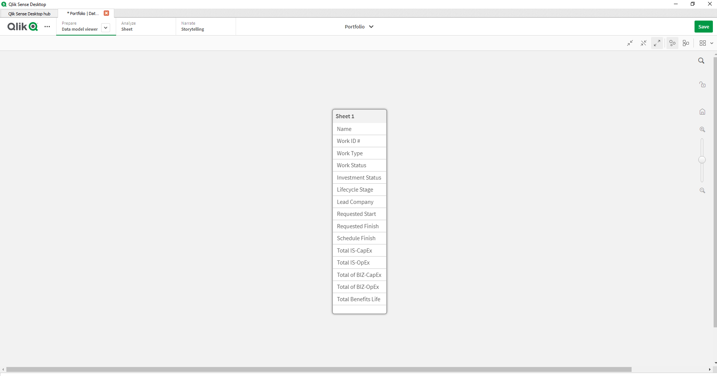

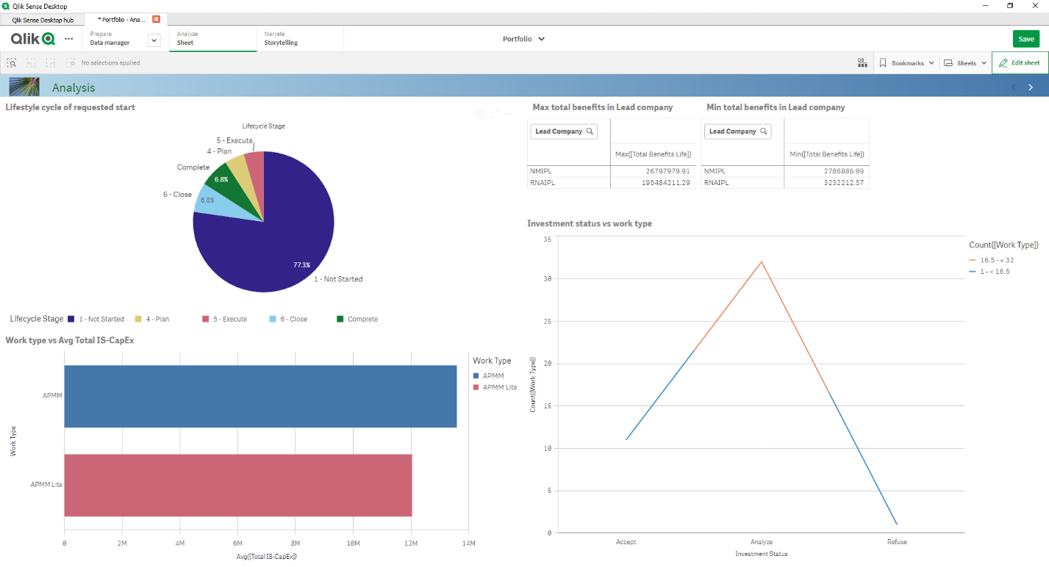

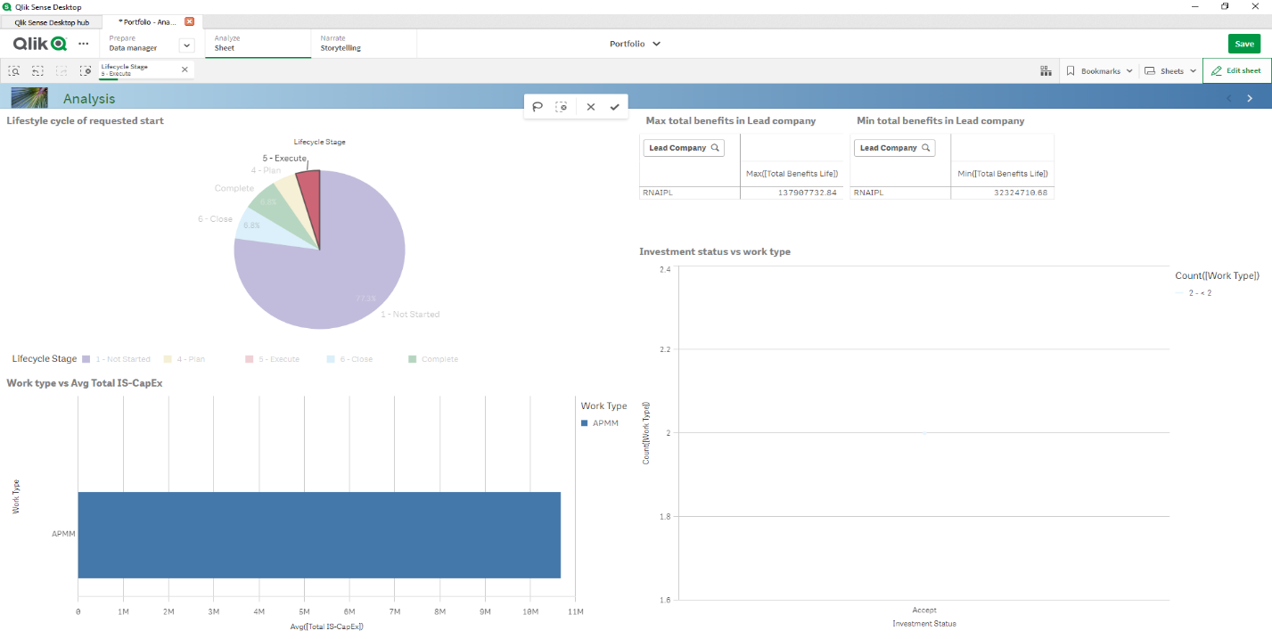

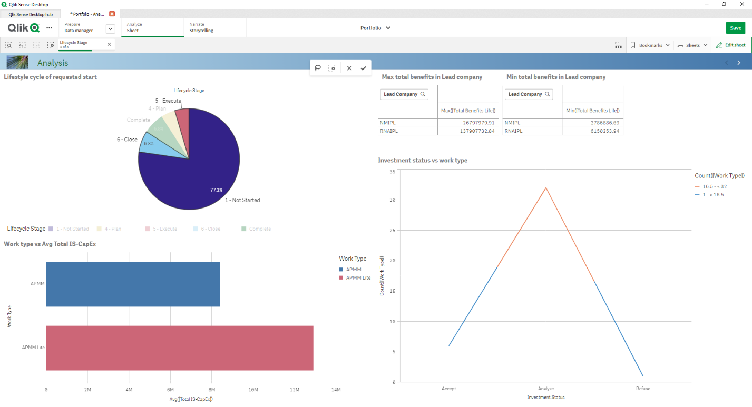

**MY WORK AS AN INTERN**

During my internship at Renault Nissan, I had the privilege of working closely with a mentor who was a data analyst of the Information System Information Technology (ISIT) team. My role primarily belonged to the ISIT, and I was taught about the framework used in Renault Nissan for data analysis. Over the course of one month, I was able to manipulate around with the employee data within specialized software. The hands-on experience allowed me to gain a deeper understanding of the company’s workforce management.

Throughout this journey, I expanded my skills significantly. I delved into Excel and Qlik, acquiring essential knowledge that I hadn’t possessed before. These newfound skills would prove valuable in various tasks and projects during my internship. One noteworthy achievement was collaborating with my fellow intern and crafting a dashboard in Qlik with the data provided by our mentor. We learned more about how to manipulate data and represent it visually pleasing and easy to understand by others.

The exposure to the company’s manufacturing facilities was a highlight of my internship. The plant tour not only deepened my appreciation of the precision and expertise that go into automobile production but also allowed me to witness the seamless integration of various departments and functions. I was able to understand how the manufacturing of cars works, and how technology plays an important role in it.

My mentor’s patient guidance provided me with valuable insights into the company’s infrastructure and hierarchy. Learning about the Qlik platform was useful to me, an engineering student pursuing a degree with a specialization in Big Data Analytics.

**CONCLUSION**

My internship at Renault Nissan was a comprehensive learning experience that exposed me to the multifaceted aspects of a global automotive giant. From data manipulation and plant tours to contributing to corporate communicative efforts, I gained valuable skills and insights that will undoubtedly shape my future. This opportunity not only broadened my horizons but also instilled in me a profound appreciation for my intricate balance of strategy, planning, and execution that drives a successful company like Renault Nissan.